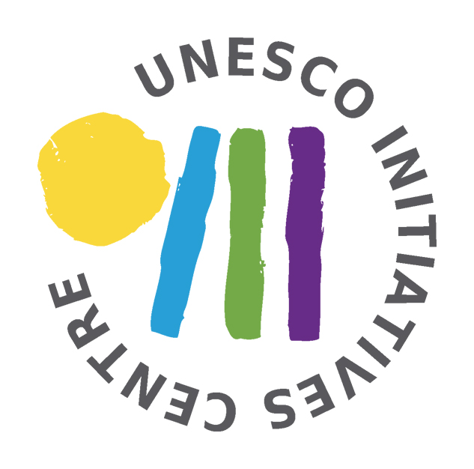


Training course '' From couch to coach“
Armenia, Yerevan
22nd - 30th April 2014

DAY 1 | DAY 2 | DAY 3 | DAY 4 | DAY 5 | DAY 6 | DAY 7 | DAY 8 | DAY 9
TUESDAY | WEDNESDAY | THURSDAY | FRIDAY | SATURDAY | SUNDAY | MONDAY | TUESDAY | WEDENSDAY
Apr, 22nd 2014 | Apr, 23rd 2014 | Apr, 24th 2014 | Apr, 25th 2014 | Apr, 26th 2014 | Apr, 27th 2014 | Apr, 28th 2014 | Apr, 29th 2014 | Apr, 30th 2014
Arrivals of participants | Getting to know each other | Who am I? | Challenge in mountains  Day 1 | Challenge in mountains  Day s | Reflection on challenge | Ideas for movies | Open Space on coaching and tutoring | Departures of participants
Arrivals of participants | Introduction to the programme | Who am I? | Challenge in mountains  Day 1 | Challenge in mountains  Day s | Practice in coaching | Working on movies | Open Space on coaching and tutoring | Departures of participants
Arrivals of participants | Teambuilding | What do I want? | Challenge in mountains  Day 1 | Challenge in mountains  Day s | Personal development | Working on movies | Youthpass and Youth in Action / Erasmus + | Departures of participants
Arrivals of participants | Teambuilding | Coaching/  Tutoring/  Mentoring | Challenge in mountains  Day 1 | Challenge in mountains  Day s | Personal development | Open space preparation | Final evaluation | Departures of participants
Welcoming evening | Intercultural evening | NGO Market | Story night | Free evening | Talent show | Movie evening | See you again party | Departures of participants

